DEPARTMENT OF AVIONICS ENGINEERING


SUBJECT : Digital Systems Microprocessors
& Microcontrollers Lab
SUBJECT CODE : 308432

TITLE : Project Report

SUBMITTED TO : Engr M. Ali Ahmed
SEMSTER : 4th
SECTION : A

Marks Obtained
 | Group Member  1 | Group Member  2 | Group Member  3
NAME | Sardar Ahmed Xareman | M. Umer Khan | M. Rahid
REGISTRATION ID | 240701019 | 240701033 | 240701037
LAB REPORT
PERFORMANCE
TOTAL MARKS

DEADLINE:
DATE OF SUBMISSION:

Contents
1. Abstract 3
2. Hardware Components 3
2.1 STM32F446RE Nucleo64 Microcontroller 3
2.2 BMP280 Digital Sensor 3
2.3 Wiring / Pin Connections 4
2.3. User Interface (Button & LED) 6
3. Software Components 7
3.1 STM32CubeMX Configuration 7
3.2 Main Software Functions & Memory Management 7
4. System Architecture and Communication Protocols 8
4.1 Sensor Communication I2C Protocol 8
4.2 Data Output UART Serial Communication 8
4.3 NonBlocking Timing Logic 8
5. Internal Flash Memory Management 8
5.1 Interrupts in Embedded Systems 9
5.2 Flash Sector Targeting and Memory Sector Layout 9
5.3 Write and Addressing Logic 9
5.4 Persistent Data Recovery on PowerOn 9
5.5 Factory Reset Sequence 10
6. User Interface and Hardware Logic 10
6.1 Button Debounce State Machine 10
6.2 Core Firmware Functions 10
7. System Algorithm & Block Diagram 10
7.1 StepbyStep Algorithm Flow 10
7.2 System Architecture Block Diagram 11
8. Hardware & Software Results 11
8.1 PuTTY Serial Terminal 11
8.2 Live Data Output in PuTTY Terminal 12
8.3 LED Visual Feedback 13
8.4 Hardware Verification via Live Debugging 13
8.5 Automated Data Visualization in Microsoft Excel 14
9. Conclusion 15
10. Code of the Project 15

1. Abstract
This project implements a standalone environmental data logger using an STM32F446RE microcontroller and a BMP280 sensor. It eliminates the need for external SD cards by utilizing the STM32’s internal flash memory for persistent data storage. The system employs a nonblocking architecture to sample temperature and pressure every 5 seconds, controlled by a hardware button interface. Upon powerup, the firmware automatically recovers all stored binary data, formats it into a Comma Separated Values (CSV) string, and transmits it via UART to a PC for direct import and automated graphing in Microsoft Excel

2. Hardware Components

2.1 STM32F446RE Nucleo64 Microcontroller
The STM32F446RE acts as the central processing unit for the system. It manages sensor polling, timing intervals, and direct memory access for permanent data storage. The onboard STLINK provides a Virtual COM Port (VCP), allowing the STM32 to act as a UART transmitter and send formatted serial data directly to the PC via the USB connection.
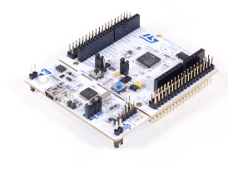
Figure 1: STM 32 F446RET6U

2.2 BMP280 Digital Sensor
- Working Principle: A piezoresistive sensor that measures absolute barometric pressure and ambient temperature.
- Data Transfer: Uses the I2C protocol configured in Standard Mode (100 kHz). 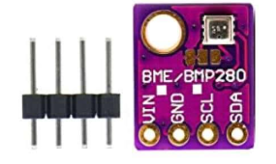
Figure 2: BMP280 Digital Sensor
BMP280 I2C Address (7-bit). The BMP280 communicates over I2C using a 7-bit address. The address is not fixed by the manufacturer; instead, it is hardware-configurable via the SDO pin. When SDO is pulled LOW (connected to GND), the sensor address is 0x76 (binary: 1110110). When SDO is pulled HIGH (connected to 3.3V), the address becomes 0x77 (binary: 1110111). The least significant bit of the address is controlled by the SDO pin, which is why two BMP280 sensors can share the same I2C bus simultaneously. In this project, the SDO pin is connected to GND on the module, so the address is fixed at 0x76.
Bosch Compensation Formula (BMP280 Internal Calculation). The BMP280 does not directly output calibrated temperature or pressure values. Instead, it returns raw ADC output values (adc_T and adc_P) as raw 20-bit integers. These raw values must be converted to physical units using the Bosch-specified compensation formulas, which apply unique per-sensor calibration coefficients stored in the sensor’s non-volatile memory registers (addresses 0x88–0x9F). The Bosch datasheet defines the following two-step integer compensation procedure for temperature:
var1 = ((adc_T / 8) – (dig_T1 * 2)) * dig_T2 / 2048;
var2 = ((adc_T / 16 – dig_T1) * (adc_T / 16 – dig_T1) / 4096) * dig_T3 / 16384;
t_fine = var1 + var2;
T (in °C) = t_fine * 5 / 100 / 64;
Where dig_T1, dig_T2, and dig_T3 are unique trimming coefficients read from the sensor’s non-volatile memory at startup. The intermediate result t_fine is also passed into the pressure compensation formula, because ambient temperature affects the MEMS pressure sensor’s output. The final calibrated temperature and pressure values returned by the driver are standard C float values, each occupying 4 bytes in memory. The open-source BMP280 driver used in this project (by Bosch Sensortec) implements these compensation formulas internally, so the firmware receives ready-to-use float values without manual computation.

2.3 Wiring / Pin Connections

The following image details the exact wiring between the BMP280 sensor module and the STM32F446RE Nucleo board. Only four wires are needed for full operation.

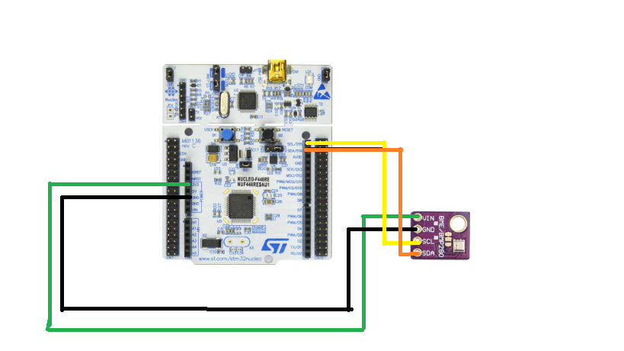
Figure 3: Digital Hardware Picture showing the Nucleo board, the BMP280, and the connecting wires

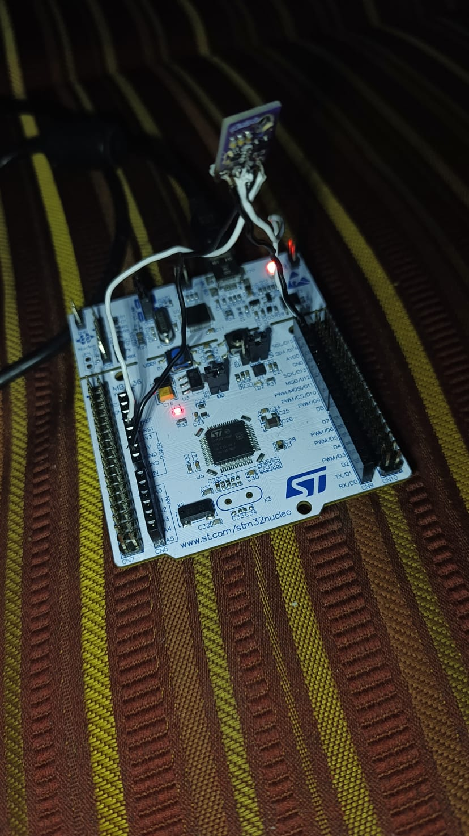
Figure 4: Actual Hardware Picture showing the Nucleo board, the BMP280, and the connecting wires
BMP280 to STM32 Pinout:
BMP280 Pin | STM32 Pin | Purpose
VCC | 3.3V | Power Supply. (Strictly 3.3V to prevent sensor damage).
GND | GND | Common ground reference.
SDA | PB9 (D14) | I2C Serial Data Line. Transmits sensor readings.
SCL | PB8 (D15) | I2C Serial Clock Line. Synchronizes data transfer.

2.3. User Interface (Button & LED)
- Working Principle: The Blue Button (PC13) acts as an input toggle for logging sessions or a hardware reset trigger. The Green LED (PA5) acts as an output to display system status.
- Output (Green LED PA5): Provides visual feedback regarding the system state. It remains constantly ON while logging is active and performs a brief 100millisecond OFF blink to confirm when a data point is successfully saved to the internal flash memory.
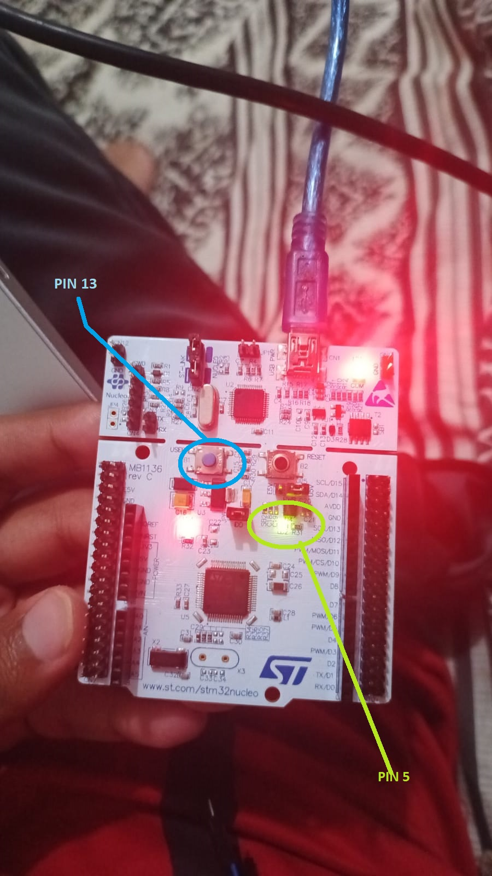

3. Software Components

3.1 STM32CubeMX Configuration

STM32CubeMX was used as the first step to configure all hardware peripherals graphically before writing any code. I2C1 was enabled on pins PB8 (SCL) and PB9 (SDA) at 100 kHz standard mode. USART2 was configured at 115200 baud with asynchronous TX/RX. GPIO was set up to drive LD2 (PA5) as a pushpull output and read the user button (PC13) as a floating input. CubeMX then automatically generated the C initialization code and the complete HAL driver framework, which was imported into STM32CubeIDE.
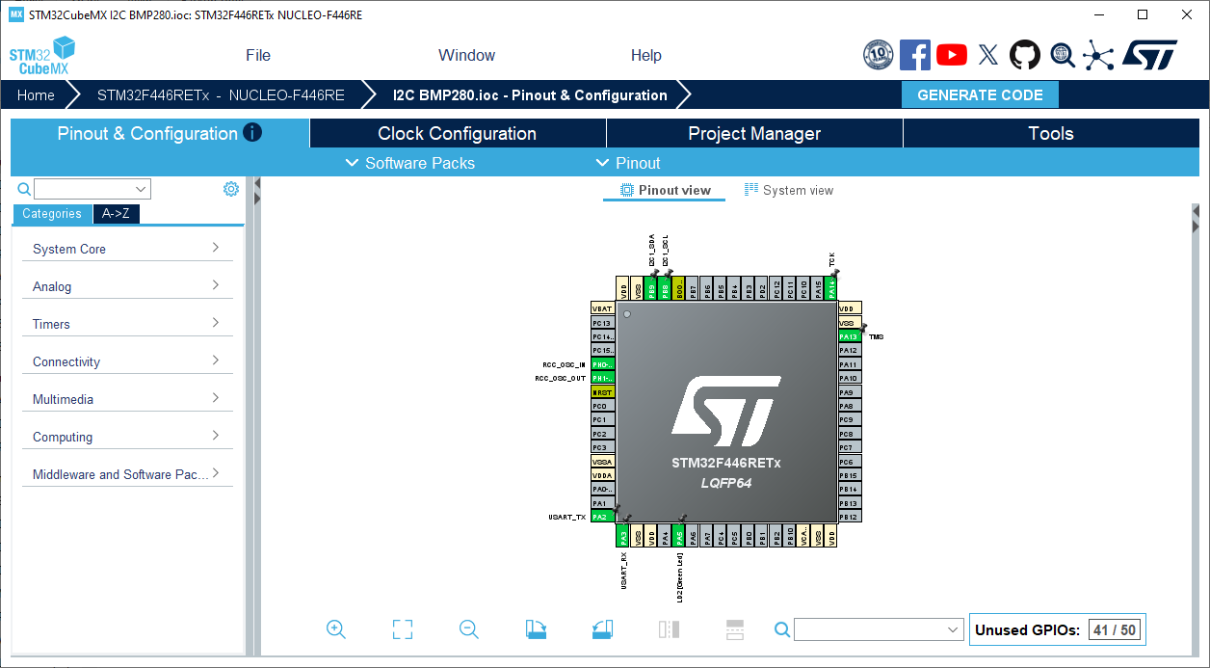
Figure 5: CubeMX Verification of the STM

3.2 Main Software Functions & Memory Management
The firmware uses the STM32 HAL library. The core functions managing the system are:
- Read_And_Print_Saved_Data()
  - Explanation: Runs automatically on startup. Scans the flash memory, extracts previously saved floats, formats them into a CSV string (Temperature_C,Pressure_Pa\r\n), and transmits them over UART.
- Save_Data_To_Flash(float temp, float press)
  - Explanation: Unlocks the flash memory, writes the 8 bytes of data (4 per float), and locks the memory again to prevent corruption.
- Erase_Flash_Sector()
  - Explanation: Executes a FLASH_TYPEERASE_SECTORS command. This resets the entire sector back to its default state (0xFFFFFFFF), making it ready for a fresh test.
- HAL_GetTick()
  - Explanation: Used for nonblocking timing. Instead of freezing the system with HAL_Delay(), it checks the system clock. This allows the processor to accurately log data every 5 seconds while remaining instantly responsive to button presses at any millisecond.

4. System Architecture and Communication Protocols

4.1 Sensor Communication I2C Protocol
The STM32F446RE communicates with the BMP280 sensor using the I2C (InterIntegrated Circuit) protocol over I2C1, configured at 100 kHz in standard mode. I2C was selected over SPI because it requires only two data wires (SDA and SCL), simplifying the hardware considerably while providing more than sufficient speed for lowfrequency environmental measurements.
During startup, the firmware executes an I2C bus scan across all 128 possible 7bit addresses. When it detects a response (HAL_OK), it stores the discovered address and uses it to initialize the BMP280 driver. The sensor's SDO pin is tied to GND, fixing its address at 0x76.

4.2 Data Output UART Serial Communication

The system uses USART2 configured at 115200 baud (8 data bits, no parity, 1 stop bit) to stream formatted text to the PC. This UART peripheral is connected through the onboard STLINK interface and appears as a Virtual COM Port (VCP) on the PC without requiring any additional hardware or USBtoserial converter.
Output is formatted as strict CSV: each line contains only the temperature value and pressure value separated by a comma, followed by a carriagereturn and linefeed. CSV headers (Temperature_C,Pressure_Pa) are injected into the stream at the start of each logging session and during the poweron export, allowing Excel to automatically recognize the columns with zero manual configuration.

4.3 NonBlocking Timing Logic
The system's 5second sampling interval is managed utilizing HAL_GetTick(). This acts as a continuous system stopwatch rather than a blocking delay (such as HAL_Delay()), allowing the processor to accurately execute the sensor polling interval while remaining instantly responsive to button inputs at any millisecond.

5. Internal Flash Memory Management
The STM32F446RE has three key memory regions: Internal Flash (512 KB @ 0x08000000) — non-volatile, stores firmware and logged data; SRAM (128 KB @ 0x20000000) — volatile runtime variables, lost on power-off; and Peripheral Registers (@ 0x40000000) — memory-mapped hardware control (UART, I2C, GPIO). Internal flash is used exclusively for data persistence as it requires no external hardware.

5.1 Interrupts in Embedded Systems
An interrupt is a signal that causes the CPU to pause its current task, execute a dedicated Interrupt Service Routine (ISR), then resume. The STM32F446RE’s ARM Cortex-M4 NVIC manages up to 240 external interrupts with configurable priorities (0 = highest). The key interrupt in this project is the SysTick, which fires every 1 ms and increments the HAL tick counter read by HAL_GetTick(). This enables the non-blocking 5-second sampling interval — unlike HAL_Delay(), the CPU remains responsive to button presses at all times. An EXTI interrupt on PC13 could also handle the button via a falling-edge trigger, but this project uses polling with a 50 ms debounce filter instead.

5.2 Flash Sector Targeting and Memory Sector Layout
The STM32F446RE contains 512 KB of internal flash divided into eight sectors of non-uniform sizes: Sectors 0–3 are 16 KB each, Sector 4 is 64 KB, and Sectors 5–7 are 128 KB each. This project targets Sector 7 (0x08060000–0x0807FFFF, 128 KB). Sector 7 was chosen specifically to avoid interfering with the application firmware stored in the lower sectors — since a sector erase destroys all 128 KB within it, placing the data logger at the top of flash guarantees it can never corrupt the running program code.

5.3 Write and Addressing Logic
Unlike RAM, flash bits can only be written from 1 → 0; restoring a 0 to 1 requires a full sector erase. The firmware therefore uses a pointer (current_flash_address) that advances by 8 bytes per write, always appending to the next empty slot. Each record is 8 bytes: 4 bytes for temperature + 4 bytes for pressure. Both values are C float types — 32-bit IEEE 754 single-precision (1 sign bit, 8 exponent bits, 23 mantissa bits) — giving ~7 decimal digits of precision. Since HAL_FLASH_Program() only accepts uint32_t, the firmware uses memcpy() to reinterpret the float’s raw bit pattern as an integer (type-punning) before writing, and reverses the same operation on read-back to reconstruct the original value with no precision loss.

5.4 Persistent Data Recovery on PowerOn

Every time the board powers on or resets, the firmware automatically scans Sector 7 starting from the base address. It reads 32bit words and checks whether each value equals 0xFFFFFFFF, which is the default erased state of flash memory. As long as the value is not 0xFFFFFFFF, the location contains valid saved data. The firmware uses memcpy() to reconstruct the original float values and immediately transmits them over UART in CSV format ensuring no data is ever lost between power cycles.

5.5 Factory Reset Sequence

To clear all stored data without connecting to a PC or IDE, a hardware factory reset sequence was implemented. If the user holds down the Blue Button before and during the board's poweron (or reset), the firmware detects the low pin state of PC13 at the very start of execution and immediately triggers HAL_FLASHEx_Erase() on Sector 7. A confirmation message is sent over UART and a 2second delay gives the user time to release the button before normal startup continues.
In practice, the procedure is: hold the Blue Button, press and release the Black (NRST) reset button once, then release the Blue Button after the LED briefly flashes or the 2second delay elapses. The sector is then fully erased and fresh logging can begin.

6. User Interface and Hardware Logic

6.1 Button Debounce State Machine

Mechanical push buttons do not produce a clean electrical signal. As the contacts make and break, they bounce rapidly between open and closed states for a few milliseconds, which can register as multiple presses if read directly. The firmware implements a 50 ms software debounce timer to solve this.
On every iteration of the main loop, the firmware reads the current pin state of PC13. If the pin state has changed from the previous reading, a debounce timestamp is saved. Only if the pin remains stable for at least 50 consecutive milliseconds is the change accepted as a genuine button press. At that point, the is_logging flag is toggled between 0 (paused) and 1 (active).

6.2 Core Firmware Functions
- Read_And_Print_Saved_Data(): Executes automatically on startup. It scans Sector 7, extracts previously saved floats, formats them into a CSV string (Temperature_C,Pressure_Pa\r\n), and transmits them over UART.
- Find_Next_Free_Flash_Address(): Scans Sector 7 to locate the first empty memory address (0xFFFFFFFF), ensuring new data is appended sequentially.
- Save_Data_To_Flash(): Unlocks the flash memory, writes the 8 bytes of data (4 bytes per temperature float, 4 bytes per pressure float), and locks the memory to prevent corruption.
- Erase_Flash_Sector(): Executes a FLASH_TYPEERASE_SECTORS command on Sector 7 to reset the 128KB sector back to its default state (0xFFFFFFFF).

7. System Algorithm & Block Diagram

7.1 StepbyStep Algorithm Flow
- Initialization: Configure System Clock, GPIO, I2C, and UART.
- Factory Reset Check: Check if the Blue Button is held down during the boot sequence. If true, execute Erase_Flash_Sector().
- Data Recovery: Read existing flash memory and export all previous session data via UART.
- Main Loop (Standby): Wait for a debounced Blue Button press.
- Logging State: If toggled ON, engage the Green LED. Every 5000 milliseconds (managed by HAL_GetTick), request data from the BMP280.
- Storage & Output: Write the acquired floats to internal Flash memory, blink the LED OFF for 100ms, and transmit the raw values over UART.
- Pause: If the Blue Button is pressed again, toggle the logging state OFF, disengage the LED, and return to Standby.

7.2 System Architecture Block Diagram
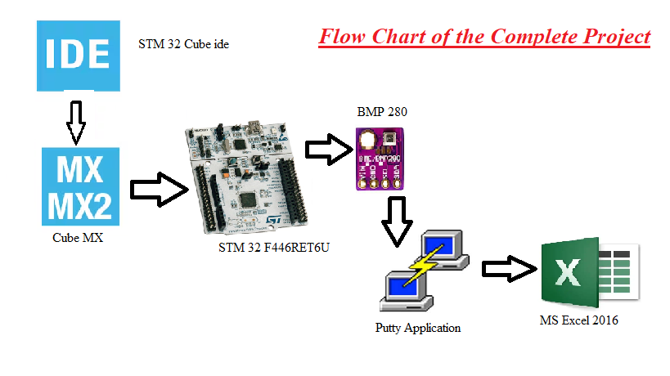
Figure 6: System Architecture Block Diagram

8. Hardware & Software Results

8.1 PuTTY Serial Terminal
PuTTY was configured as a Serial connection on COM6 at 115200 baud to display and capture the live UART output from the board. Because PuTTY can log all received text to a file, each logging session's output was saved directly as a .csv file. The STM32 firmware was designed so that the first line it sends at the start of a session is the CSV header row (Temperature_C,Pressure_Pa), which means the saved file can be opened directly in Excel with no preprocessing the data is immediately ready for charting.
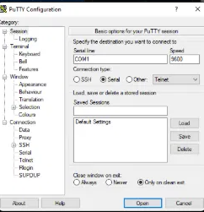
Figure 7: Putty Interfacce

8.2 Live Data Output in PuTTY Terminal

The screenshot below shows a live logging session in PuTTY. Each line output by the STM32 follows the format value,value with the LIVE prefix stripped in the final CSV output. The logging started and paused markers are visible, confirming the button toggle functionality works correctly. The STM32 successfully transmitted acquired data to the PC at a baud rate of 115200. The PuTTY terminal output displayed CSV headers followed by precise sensor readings updating every 5 seconds. The custom LOGGING STARTED and LOGGING PAUSED text markers verified the proper execution of the debounced state machine logic.
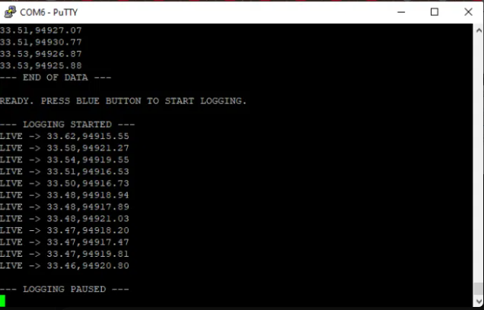
Figure 8: Putty Value Monitor

8.3 LED Visual Feedback

The onboard Green LED (LD2, PA5) serves as the primary status indicator. When a logging session starts, the LED is turned on continuously, giving a clear visible signal that the system is actively acquiring and saving data. Every 5 seconds when a reading is captured and written to flash, the LED briefly switches off for 100 milliseconds before returning to steady on providing an inverted blink that confirms each successful flash write. When the button is pressed a second time to stop logging, the LED turns off entirely until the next session begins.

8.4 Hardware Verification via Live Debugging
The system's firmware was verified using STM32CubeIDE's live debugging feature via the STLINK interface. By setting breakpoints in the code, critical variables like the live sensor readings (temperature_c, pressure_pa) and the flash memory address were monitored in realtime directly from the microcontroller's RAM. The figure below shows the debugging interface actively pausing execution to validate the environmental data right before it is saved to memory.
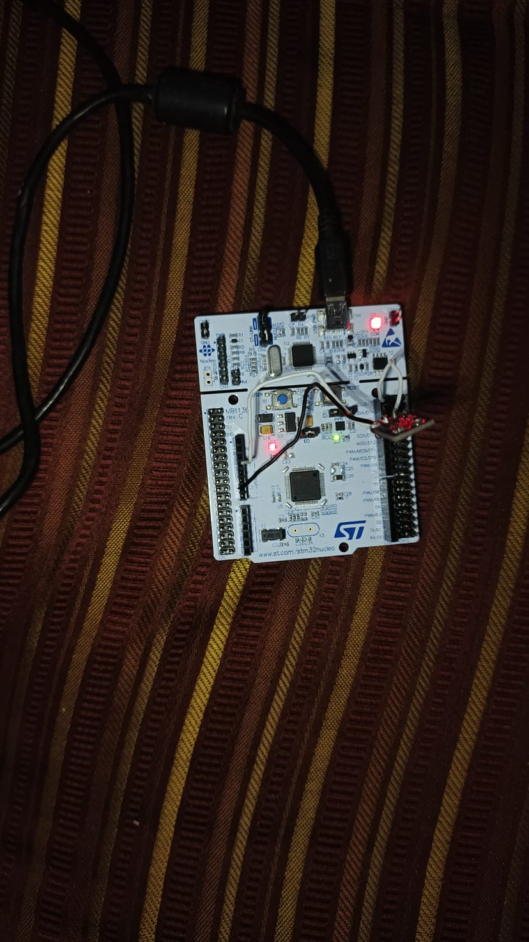
Figure 9: Working Hardware of the Project
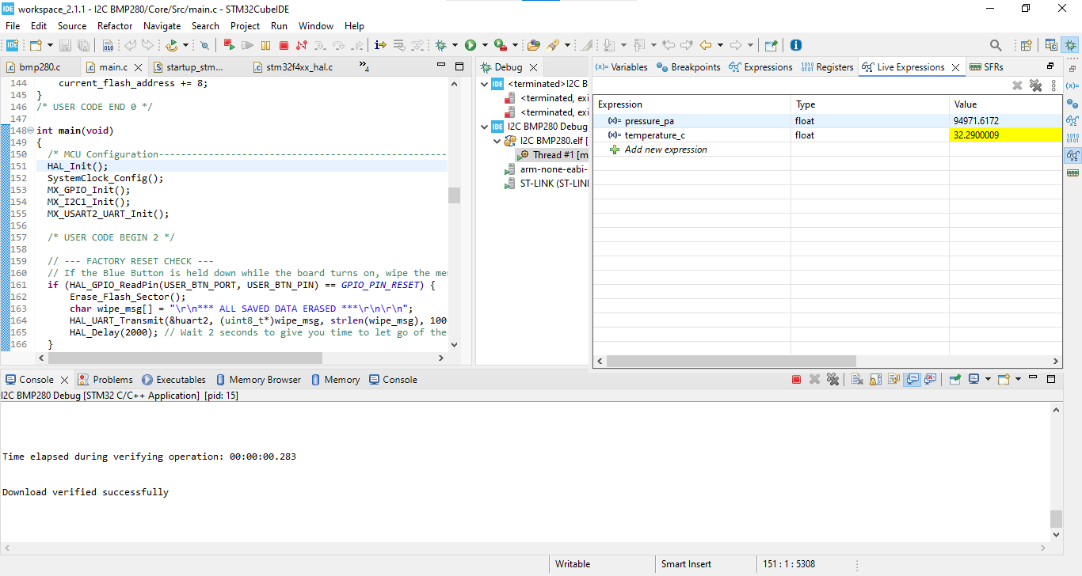
Figure 10: Live Debugging in the STM 32 Cube IDE

8.5 Automated Data Visualization in Microsoft Excel
The Putty natively formatted the serial data as a commaseparated string, allowing the resulting .csv log files to be imported directly into Microsoft Excel without manual data parsing. The automatically generated line charts successfully tracked thermal variations, clearly displaying a temperature curve when the sensor was exposed to a heat source followed by its subsequent cooling period.
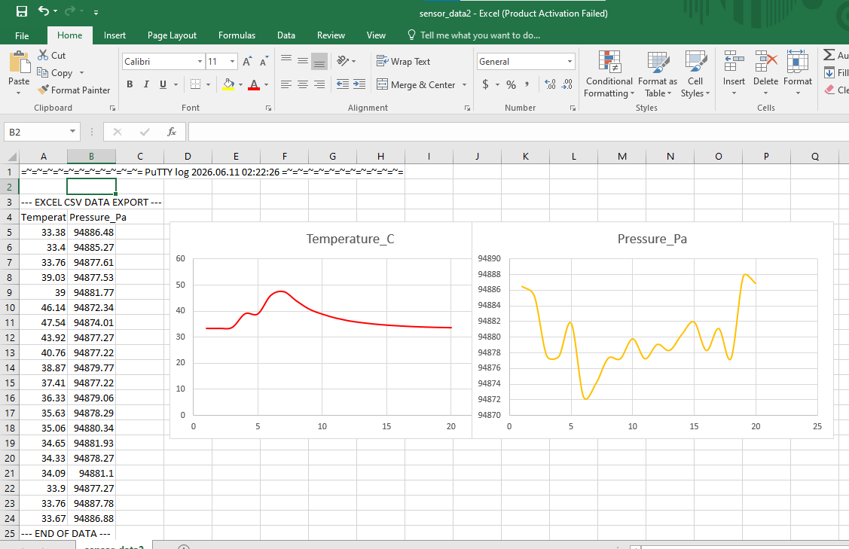
Figure 11 Excel Data INPUT and Graphs

9. Conclusion
This project successfully demonstrated the development of a highly robust, baremetal embedded data acquisition system. By utilizing the STM32's internal flash memory alongside a nonblocking timing architecture. Furthermore, by managing the CSV formatting directly on the microcontroller firmware, the system proved that embedded hardware can seamlessly interface with standard PC data analysis tools without requiring intermediate processing software.

10. Code of the Project

/* USER CODE BEGIN Header */
/**
******************************************************************************
* @file : main.c
* @brief : Main program body
******************************************************************************
*/
/* USER CODE END Header */
/* Includes ------------------------------------------------------------------*/
#include "main.h"

/* Private includes ----------------------------------------------------------*/
/* USER CODE BEGIN Includes */
#include <stdio.h>
#include <string.h> // Required for memcpy
#include "bmp280.h" // Connects the driver types and functions to main.c
/* USER CODE END Includes */

/* Private typedef -----------------------------------------------------------*/
/* USER CODE BEGIN PTD */

/* USER CODE END PTD */

/* Private define ------------------------------------------------------------*/
/* USER CODE BEGIN PD */

/* This configuration targets Sector 7 of the STM32F446RE internal flash memory.
Storing data in the final 128KB sector physically isolates the saved sensor
readings from the main application firmware located in Sector 0. This completely
eliminates the risk of accidentally corrupting the program code during memory writes.
*/
#define FLASH_SECTOR_7_ADDR 0x08060000
#define FLASH_SECTOR_7_END 0x0807FFFF

/* Blue User Button on Nucleo is PC13 */
#define USER_BTN_PIN GPIO_PIN_13
#define USER_BTN_PORT GPIOC
/* USER CODE END PD */

/* Private macro -------------------------------------------------------------*/
/* USER CODE BEGIN PM */

/* USER CODE END PM */

/* Private variables ---------------------------------------------------------*/
I2C_HandleTypeDef hi2c1;
UART_HandleTypeDef huart2;

/* USER CODE BEGIN PV */
BMP280_HandleTypedef bmp280_dev;
bmp280_params_t bmp280_config;

float temperature_c = 0.0;
float pressure_pa = 0.0;
uint8_t discovered_address = 0;

uint32_t current_flash_address = FLASH_SECTOR_7_ADDR;
uint32_t previous_time = 0;

// Variables for Button Logic
uint8_t is_logging = 0; // 0 = Paused/Stopped, 1 = Logging
uint8_t button_state = 1; // Nucleo button is usually HIGH when unpressed
uint8_t last_button_state = 1;
uint32_t last_debounce_time = 0;
/* USER CODE END PV */

/* Private function prototypes -----------------------------------------------*/
void SystemClock_Config(void);
static void MX_GPIO_Init(void);
static void MX_I2C1_Init(void);
static void MX_USART2_UART_Init(void);
/* USER CODE BEGIN PFP */
void Read_And_Print_Saved_Data(void);
void Find_Next_Free_Flash_Address(void);
void Save_Data_To_Flash(float temp, float press);
void Erase_Flash_Sector(void);
/* USER CODE END PFP */

/* Private user code ---------------------------------------------------------*/
/* USER CODE BEGIN 0 */

/*
On boot, the system scans the targeted flash memory sector to recover previous
sessions. An unwritten or erased flash memory word defaults to 0xFFFFFFFF.
When valid binary data is found, memcpy is used to reconstruct the exact
floating-point precision back into variables. The data is then formatted natively
with comma separators and transmitted over UART, allowing standard PC software
like Microsoft Excel to instantly parse the serial stream as a CSV file.
*/
void Read_And_Print_Saved_Data(void) {
char uart_buf[64];
uint32_t read_addr = FLASH_SECTOR_7_ADDR;

sprintf(uart_buf, "\r\n--- PREVIOUS SESSION EXPORT ---\r\n");
HAL_UART_Transmit(&huart2, (uint8_t*)uart_buf, strlen(uart_buf), 100);

// Print the Headers for Excel
sprintf(uart_buf, "Temperature_C,Pressure_Pa\r\n");
HAL_UART_Transmit(&huart2, (uint8_t*)uart_buf, strlen(uart_buf), 100);

// Read until we hit an empty flash word (0xFFFFFFFF) or the end of the sector
while (*(__IO uint32_t*)read_addr != 0xFFFFFFFF && read_addr < FLASH_SECTOR_7_END) {
float saved_temp, saved_press;

memcpy(&saved_temp, (void*)read_addr, 4);
memcpy(&saved_press, (void*)(read_addr + 4), 4);

// Print as CSV (Comma Separated)
sprintf(uart_buf, "%.2f,%.2f\r\n", saved_temp, saved_press);
HAL_UART_Transmit(&huart2, (uint8_t*)uart_buf, strlen(uart_buf), 100);

read_addr += 8;
}

sprintf(uart_buf, "--- END OF DATA ---\r\n\r\n");
HAL_UART_Transmit(&huart2, (uint8_t*)uart_buf, strlen(uart_buf), 100);

sprintf(uart_buf, "READY. PRESS BLUE BUTTON TO START LOGGING.\r\n");
HAL_UART_Transmit(&huart2, (uint8_t*)uart_buf, strlen(uart_buf), 100);
}

/*
To prevent overwriting existing data, this function continuously increments a
pointer until it locates the first blank 0xFFFFFFFF slot. It advances the pointer
by 8 bytes during each iteration because the system saves pairs of floating-point
variables, and a standard C float occupies exactly 4 bytes of memory.
*/
void Find_Next_Free_Flash_Address(void) {
current_flash_address = FLASH_SECTOR_7_ADDR;
while (*(__IO uint32_t*)current_flash_address != 0xFFFFFFFF) {
current_flash_address += 8;
if (current_flash_address >= FLASH_SECTOR_7_END) {
break;
}
}
}

/*
Flash memory cannot be selectively overwritten byte-by-byte like standard RAM;
an entire sector must be wiped simultaneously. This routine unlocks the silicon,
configures the hardware to erase all 128KB of Sector 7 back to a logical high
state, and immediately locks the memory controller again to prevent any accidental
data corruption from stray pointers.
*/
void Erase_Flash_Sector(void) {
HAL_FLASH_Unlock();
FLASH_EraseInitTypeDef EraseInitStruct;
uint32_t SectorError;
EraseInitStruct.TypeErase = FLASH_TYPEERASE_SECTORS;
EraseInitStruct.VoltageRange = FLASH_VOLTAGE_RANGE_3;
EraseInitStruct.Sector = FLASH_SECTOR_7;
EraseInitStruct.NbSectors = 1;
HAL_FLASHEx_Erase(&EraseInitStruct, &SectorError);
HAL_FLASH_Lock();
current_flash_address = FLASH_SECTOR_7_ADDR;
}

/*
The STM32 flash programming hardware strictly requires 32-bit integer inputs.
Directly casting a float to an integer would truncate and destroy the decimal
precision of the sensor reading. Utilizing memcpy safely copies the exact IEEE-754
binary bit pattern from the float variable into the integer container, ensuring
the true measured value is perfectly preserved when written to the silicon.
*/
void Save_Data_To_Flash(float temp, float press) {
if (current_flash_address >= (FLASH_SECTOR_7_END - 8)) {
Erase_Flash_Sector();
}
HAL_FLASH_Unlock();
uint32_t t_data, p_data;
memcpy(&t_data, &temp, 4);
memcpy(&p_data, &press, 4);
HAL_FLASH_Program(FLASH_TYPEPROGRAM_WORD, current_flash_address, t_data);
HAL_FLASH_Program(FLASH_TYPEPROGRAM_WORD, current_flash_address + 4, p_data);
HAL_FLASH_Lock();
current_flash_address += 8;
}
/* USER CODE END 0 */

int main(void)
{
/* MCU Configuration--------------------------------------------------------*/
HAL_Init();
SystemClock_Config();
MX_GPIO_Init();
MX_I2C1_Init();
MX_USART2_UART_Init();

/* USER CODE BEGIN 2 */

/*
By reading the pin state before the system enters the infinite main loop, a
standalone hardware reset sequence is established. If the user holds the
onboard button while the board is powered on or reset, it immediately triggers
the flash erase function, providing a field-ready way to clear memory without
requiring connection to a PC or programming IDE.
*/
// --- FACTORY RESET CHECK ---
if (HAL_GPIO_ReadPin(USER_BTN_PORT, USER_BTN_PIN) == GPIO_PIN_RESET) {
Erase_Flash_Sector();
char wipe_msg[] = "\r\n*** ALL SAVED DATA ERASED ***\r\n\r\n";
HAL_UART_Transmit(&huart2, (uint8_t*)wipe_msg, strlen(wipe_msg), 100);
HAL_Delay(2000); // Wait 2 seconds to give you time to let go of the button
}

/*
Instead of hardcoding a specific sensor I2C address, the system systematically
pings the I2C bus during startup. If a device acknowledges the transmission,
its address is dynamically recorded. This makes the firmware highly adaptable
and robust to different manufacturers' BMP280 modules which may have varying
default addresses based on their internal SDO pin wiring.
*/
// 1. I2C Scanner
for(uint8_t i = 1; i < 128; i++) {
if(HAL_I2C_IsDeviceReady(&hi2c1, (uint16_t)(i<<1), 3, 5) == HAL_OK) {
discovered_address = i;
}
}

// 2. Sensor Init
bmp280_init_default_params(&bmp280_config);
bmp280_dev.i2c = &hi2c1;
if (discovered_address == 119) {
bmp280_dev.addr = BMP280_I2C_ADDRESS_1;
} else {
bmp280_dev.addr = BMP280_I2C_ADDRESS_0;
}
bmp280_init(&bmp280_dev, &bmp280_config);

// 3. Flash Memory Setup
Read_And_Print_Saved_Data();
Find_Next_Free_Flash_Address();

/* USER CODE END 2 */

/* Infinite loop */
/* USER CODE BEGIN WHILE */
while (1)
{
/*
Mechanical switch contacts naturally bounce and vibrate when pressed,
creating rapid voltage spikes that a microcontroller reads as hundreds of
individual presses. By recording the timestamp of the first state change
and requiring the electrical signal to remain completely stable for 50
continuous milliseconds, the software ensures that only deliberate, physical
human actions alter the logging state machine.
*/
// --- BUTTON DEBOUNCE & TOGGLE LOGIC ---
uint8_t current_reading = HAL_GPIO_ReadPin(USER_BTN_PORT, USER_BTN_PIN);

// If the switch changed, reset the debounce timer
if (current_reading != last_button_state) {
last_debounce_time = HAL_GetTick();
}

// If the state has been stable for 50 milliseconds
if ((HAL_GetTick() - last_debounce_time) > 50) {
if (current_reading != button_state) {
button_state = current_reading;

// Nucleo Blue Button goes to 0 (RESET) when pressed
if (button_state == GPIO_PIN_RESET) {
is_logging = !is_logging; // Toggle Logging State!

char uart_buf[128];
if (is_logging) {
// Turn LED ON continuously while logging
HAL_GPIO_WritePin(LD2_GPIO_Port, LD2_Pin, GPIO_PIN_SET);
// Print Headers for the new LIVE data
sprintf(uart_buf, "\r\n--- LOGGING STARTED ---\r\nTemperature_C,Pressure_Pa\r\n");
previous_time = HAL_GetTick(); // Reset timer instantly
} else {
// Force the green LED OFF when stopped
HAL_GPIO_WritePin(LD2_GPIO_Port, LD2_Pin, GPIO_PIN_RESET);
sprintf(uart_buf, "\r\n--- LOGGING STOPPED ---\r\n");
}
HAL_UART_Transmit(&huart2, (uint8_t*)uart_buf, strlen(uart_buf), 100);
}
}
}
last_button_state = current_reading;

/*
Relying on standard delay functions like HAL_Delay completely halts the
processor, effectively making the hardware blind to button inputs while
waiting. By checking the difference against HAL_GetTick, the system creates
a non-blocking stopwatch. This architectural choice permits the main loop
to run at maximum speed to monitor the user interface instantly, while still
triggering precision data acquisition exactly every 5000 milliseconds.
*/
// --- NON-BLOCKING 5-SECOND TIMER ---
if (is_logging == 1 && (HAL_GetTick() - previous_time >= 5000))
{
previous_time = HAL_GetTick(); // Reset the timer

if (bmp280_read_float(&bmp280_dev, &temperature_c, &pressure_pa, NULL))
{
// 1. Turn OFF the Green LED to show we are capturing a value (inverted blink)
HAL_GPIO_WritePin(LD2_GPIO_Port, LD2_Pin, GPIO_PIN_RESET);

char uart_buf[64];
// 2. Print pure numbers in CSV format (No text!)
int len = sprintf(uart_buf, "%.2f,%.2f\r\n", temperature_c, pressure_pa);
HAL_UART_Transmit(&huart2, (uint8_t*)uart_buf, len, 100);

// 3. Save to memory
Save_Data_To_Flash(temperature_c, pressure_pa);

// 4. Wait 100 milliseconds, then turn it back ON
HAL_Delay(100);
HAL_GPIO_WritePin(LD2_GPIO_Port, LD2_Pin, GPIO_PIN_SET);
}
}

/* USER CODE END WHILE */

/* USER CODE BEGIN 3 */
}
/* USER CODE END 3 */
}

void SystemClock_Config(void)
{
RCC_OscInitTypeDef RCC_OscInitStruct = {0};
RCC_ClkInitTypeDef RCC_ClkInitStruct = {0};
__HAL_RCC_PWR_CLK_ENABLE();
__HAL_PWR_VOLTAGESCALING_CONFIG(PWR_REGULATOR_VOLTAGE_SCALE3);
RCC_OscInitStruct.OscillatorType = RCC_OSCILLATORTYPE_HSI;
RCC_OscInitStruct.HSIState = RCC_HSI_ON;
RCC_OscInitStruct.HSICalibrationValue = RCC_HSICALIBRATION_DEFAULT;
RCC_OscInitStruct.PLL.PLLState = RCC_PLL_ON;
RCC_OscInitStruct.PLL.PLLSource = RCC_PLLSOURCE_HSI;
RCC_OscInitStruct.PLL.PLLM = 8;
RCC_OscInitStruct.PLL.PLLN = 80;
RCC_OscInitStruct.PLL.PLLP = RCC_PLLP_DIV4;
RCC_OscInitStruct.PLL.PLLQ = 2;
RCC_OscInitStruct.PLL.PLLR = 2;
if (HAL_RCC_OscConfig(&RCC_OscInitStruct) != HAL_OK)
{
Error_Handler();
}
RCC_ClkInitStruct.ClockType = RCC_CLOCKTYPE_HCLK|RCC_CLOCKTYPE_SYSCLK
|RCC_CLOCKTYPE_PCLK1|RCC_CLOCKTYPE_PCLK2;
RCC_ClkInitStruct.SYSCLKSource = RCC_SYSCLKSOURCE_PLLRCLK;
RCC_ClkInitStruct.AHBCLKDivider = RCC_SYSCLK_DIV1;
RCC_ClkInitStruct.APB1CLKDivider = RCC_HCLK_DIV2;
RCC_ClkInitStruct.APB2CLKDivider = RCC_HCLK_DIV1;
if (HAL_RCC_ClockConfig(&RCC_ClkInitStruct, FLASH_LATENCY_2) != HAL_OK)
{
Error_Handler();
}
}

static void MX_I2C1_Init(void)
{
hi2c1.Instance = I2C1;
hi2c1.Init.ClockSpeed = 100000;
hi2c1.Init.DutyCycle = I2C_DUTYCYCLE_2;
hi2c1.Init.OwnAddress1 = 0;
hi2c1.Init.AddressingMode = I2C_ADDRESSINGMODE_7BIT;
hi2c1.Init.DualAddressMode = I2C_DUALADDRESS_DISABLE;
hi2c1.Init.OwnAddress2 = 0;
hi2c1.Init.GeneralCallMode = I2C_GENERALCALL_DISABLE;
hi2c1.Init.NoStretchMode = I2C_NOSTRETCH_DISABLE;
if (HAL_I2C_Init(&hi2c1) != HAL_OK)
{
Error_Handler();
}
}

static void MX_USART2_UART_Init(void)
{
huart2.Instance = USART2;
huart2.Init.BaudRate = 115200;
huart2.Init.WordLength = UART_WORDLENGTH_8B;
huart2.Init.StopBits = UART_STOPBITS_1;
huart2.Init.Parity = UART_PARITY_NONE;
huart2.Init.Mode = UART_MODE_TX_RX;
huart2.Init.HwFlowCtl = UART_HWCONTROL_NONE;
huart2.Init.OverSampling = UART_OVERSAMPLING_16;
if (HAL_UART_Init(&huart2) != HAL_OK)
{
Error_Handler();
}
}

static void MX_GPIO_Init(void)
{
GPIO_InitTypeDef GPIO_InitStruct = {0};

__HAL_RCC_GPIOC_CLK_ENABLE();
__HAL_RCC_GPIOH_CLK_ENABLE();
__HAL_RCC_GPIOA_CLK_ENABLE();
__HAL_RCC_GPIOB_CLK_ENABLE();

HAL_GPIO_WritePin(LD2_GPIO_Port, LD2_Pin, GPIO_PIN_RESET);

GPIO_InitStruct.Pin = USER_BTN_PIN;
GPIO_InitStruct.Mode = GPIO_MODE_INPUT;
GPIO_InitStruct.Pull = GPIO_NOPULL;
HAL_GPIO_Init(USER_BTN_PORT, &GPIO_InitStruct);

GPIO_InitStruct.Pin = LD2_Pin;
GPIO_InitStruct.Mode = GPIO_MODE_OUTPUT_PP;
GPIO_InitStruct.Pull = GPIO_NOPULL;
GPIO_InitStruct.Speed = GPIO_SPEED_FREQ_LOW;
HAL_GPIO_Init(LD2_GPIO_Port, &GPIO_InitStruct);
}

void Error_Handler(void)
{
__disable_irq();
while (1)
{
}
}

#ifdef USE_FULL_ASSERT
void assert_failed(uint8_t *file, uint32_t line)
{
}
#endif /* USE_FULL_ASSERT */

